Hybrid FEM MATLAB/Simulink Manual

The Hybrid FEM program runs under MATLAB and Simulink (R2007b) and is compatible with Target PC for real-time applications. It consists of a Structure, Elements and an Integrator for running the pseudo-dynamic simulation. A Simulink library called ‘HybridFEMLibrary.mdl’ contains all blocks that can be used to develop a complete Hybrid FEM system for simulation. A MATLAB M-file called ‘HybridFEMSetup.m’ contains all the initialization for the blocks in the Simulink library.

Inside the package
The Hybrid FEM program consists of many MATLAB M-files and a MDL Simulink library file. It is also packaged with two examples under the Systems folder.
- CalculateBandwidth.m: Calculates the bandwidth of the Structure for use in calculating the stiffness matrix.
- CalculateMatrices.m: Forms the integration matrices.
- CreateElement_TypeN.m: Creates each type of Element object.
- CreateIntegrator.m: Creates the Integrator object.
- CreateMaterial.m: Creates the Material object inside an Element.
- CreateNode.m: Creates a single Node object with coordinates.
- CreateStructure.m: Creates a Structure object.
- FormElementMatrices_TypeN.m: Forms the Element matrices per type.
- GetEQHistory.m Loads the earthquake acceleration record.
- InitializeIntegrator.m: Initializes the memory used for the integration algorithm.
- LoadConfiguration.m: Reads the INP configuration file and sets up the Structure, Element and Integrator objects.
- HybridFEMSetup.m: Uses all the files above to configure a complete Hybrid FEM system for use with the Simulink library available.
- HybridFEMLibrary.mdl: The Hybrid FEM Simulink library which contains all the available blocks to complete a system for simulation.

Hybrid FEM Simulink Library

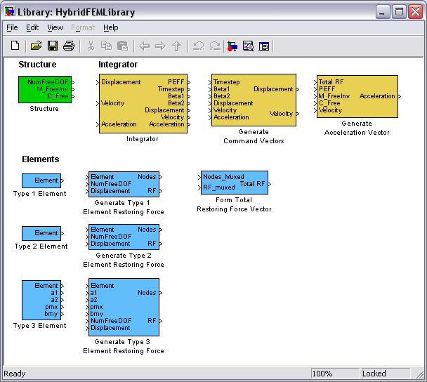

Each block references the MATLAB workspace which contains the objects and variables generated through the ‘HybridFEMSetup.m’ script. In Simulink, each block contains a description and tips on how to use it. These can be view by double clicking any block.

Example System – HybridFEMModel.mdl
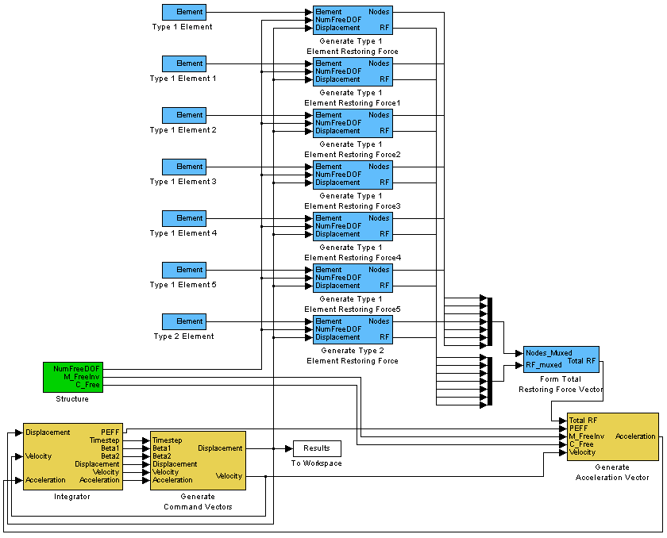

In the above system, the yellow blocks represent parts of the CR Integration algorithm. The Integrator block connects to the Generate Command Vectors block. Above those blocks are the blue Element blocks. The element types, order and number is determined from the INP file. A Type N Element block must always match up with a Generate Type N Element Restoring Force block. The user must double click each Type N Element to define its ID. This is found in the INP file. Since each element has its restoring force calculated in parallel, all the restoring force and node outputs of each Generate Type N Element Restoring Force block must be multiplexed and used as the input to the Form Total Restoring Force Vector block. The output of that block is then used as the input for the Generate Acceleration Vector block. The Acceleration output is then fed back to the Integrator block to calculate the next step commands. Also, a Structure block is required as input for the Generate Type N Element Restoring Force blocks and the Generate Acceleration Vector block.

To interface with this model, the user can take the Displacement output from the Generate Command Vectors block. In order to receive real-world restoring forces, a new Element type must be developed along with new Type N Element and Generate Type N Element Restoring Force blocks.

To run this example, use the following instructions:
- Open MATLAB
- Go to the HybridFEM/Systems/ExampleSystem folder
- Run ‘HybridFEMSetup_1.m’. This will run the model automatically.
- To observe and run the model independently, open ‘HybridFEMModel_1.m’ and remove the sim(‘HybridFEMModel_1’) line in ‘HybridFEMSetup_1.m’.

